

**ST. PAUL’S UNIVERSITY**

**NAIROBI CAMPUS**

**EVENING PROGRAMME**

**SCHOOL OF COMMUNICATION AND COMPUTER STUDIES**

**DEPARTMENT OF COMPUTER STUDIES**

**BIT 2208: SOFTWARE ENGINEERING 1**

**GROUP 2: TUCKSHOP MOBILE APPLICATION REPORT**

**STUDENT NAMES & NUMBERS:**

**BENJAMIN MULINGE KYALO - BOBITNRB154224**

**LELA KEMUNTO GEKE - BOBITNRB277023**

**JAFETH SAKA - BOBITNRB217923**

**RAHMA JAMA - BOBITNRB228623**

**LECTURER: CECILIA ANGELA NANFUKA**

**DATE OF SUBMISSION: November 22, 2024**

# **INTRODUCTION**

The Maelezo Tuckshop mobile application is designed to make the process of ordering snacks, drinks and stationery items easier. This solution aims to enhance user convenience by providing a proper online shopping experience, complete with real-time orders and multiple payment options. The application ensures a user-friendly interface and efficient functionality, catering to the needs of both customers and the tuckshop administrators.

# **ESTIMATION TECHNIQUE**

The estimation technique that was used for the development of this project was the *Agile Estimation Technique*. Agile estimation is a popular method used in software development to provide more flexible and accurate project timelines. It involves breaking down the project into smaller tasks and then estimating the effort required for each task. This method allowed for iterative development and continuous feedback, ensuring the project stayed on track and was able to adjust to any changes or new requirements that were introduced.

# **SOFTWARE REQUIREMENTS SPECIFICATION**

The Maelezo University Tuckshop Application is designed to provide a proper experience for users to browse, order, and pay for items available in a tuckshop. It aims to offer a mobile-friendly interface with integrated payment options and real-time order updates.

**Objectives**

* To provide a user-friendly interface for ordering tuckshop items.
* To integrate with Firebase for data storage and retrieval.
* To offer multiple payment methods for user convenience.
* To notify users once their order is ready.

**Functional Requirements**

1. **User Interface**

* A scrollable list of items with details like name, category, price, and offers.
* Buttons to place orders and refresh the item list.
* Popups for order details, payment methods, and order confirmation.

1. **Data Management**

* Integration with Firebase to store and retrieve item data.
* Functions to add and fetch items from the Firebase database.

1. **Order Processing**

* Calculation of the total amount based on the quantity and price.
* Multiple payment options including Cash Transaction, M-PESA and Airtel Money.
* Confirmation of successful payments and order placements.

**Non-Functional Requirements**

1. **Usability**

The application should be easy to navigate, with a clean and intuitive interface.

1. **Performance**

The application should load quickly and handle user interactions smoothly.

1. **Security**

User data, especially payment details, should be handled securely.

1. **Scalability**

The application should handle a growing number of items and user interactions without performance degradation.

# **SEQUENCE DIAGRAM**

Below is a representation of a sequence diagram showing how a user will be alerted once their order is ready:

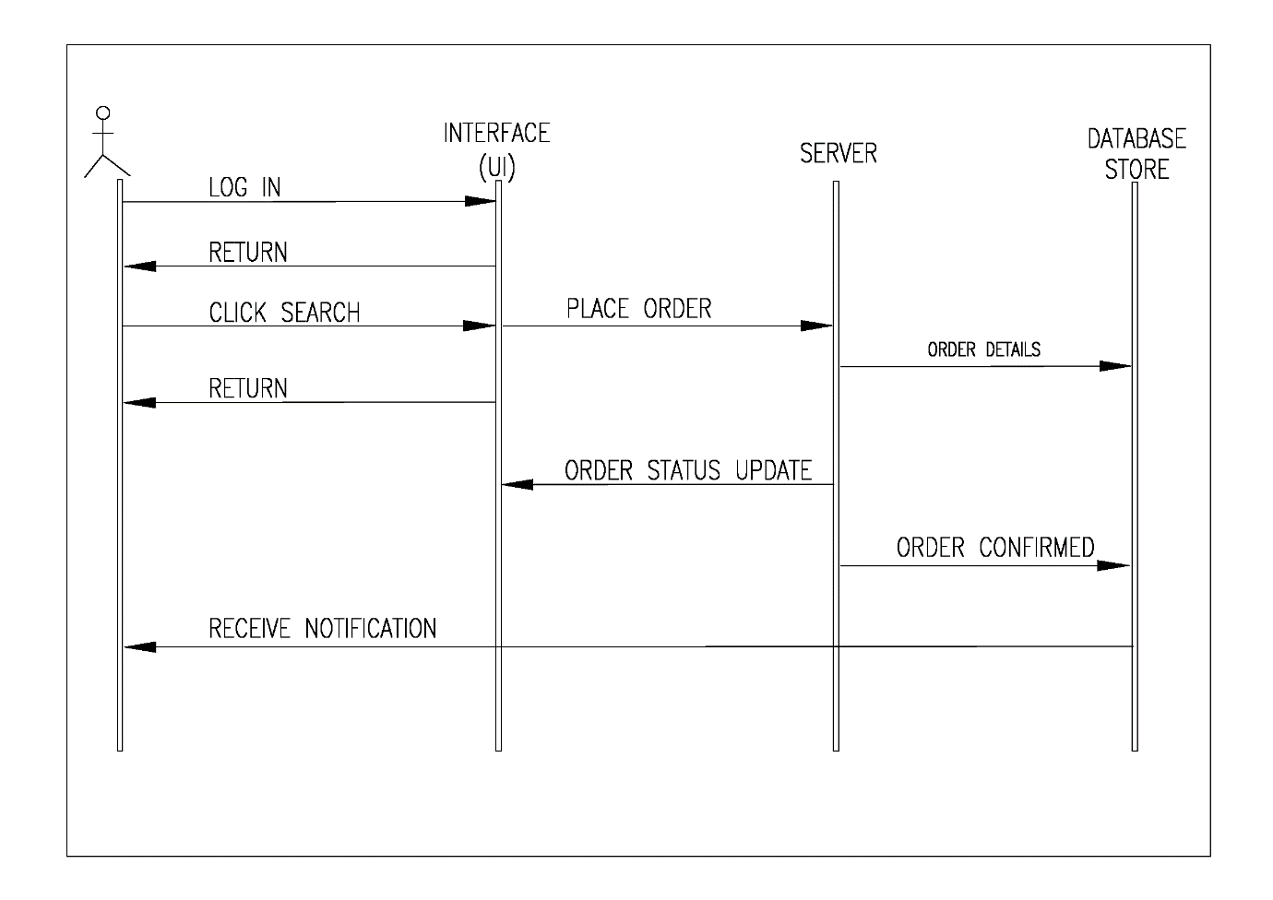

# **CONCLUSION**

The Maelezo Tuckshop mobile application offers a comprehensive and efficient solution for managing tuckshop orders. By the use of Agile estimation technique, we ensured accurate project planning and flexibility. The application meets essential functional and non-functional requirements, providing users with a reliable and user-friendly platform for their ordering needs, enhancing their overall experience.

# **GITHUB LINK**

To access the complete project and its documentation visit the GitHub link below:

<https://github.com/BenjaminMulingeKyalo/BIT-2208-GROUP2-SE1>